Chapter 9, Problem 70.

Find the equivalent impedance of the circuit in Fig. 9.77.

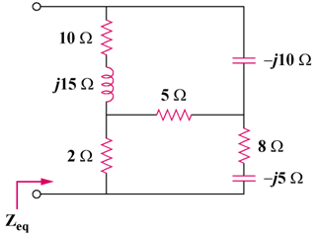

Figure 9.77
For Prob. 9.77.

